Name :Sk.Kashifa

Register no :192121135

Hospital Management system :

Class diagram :

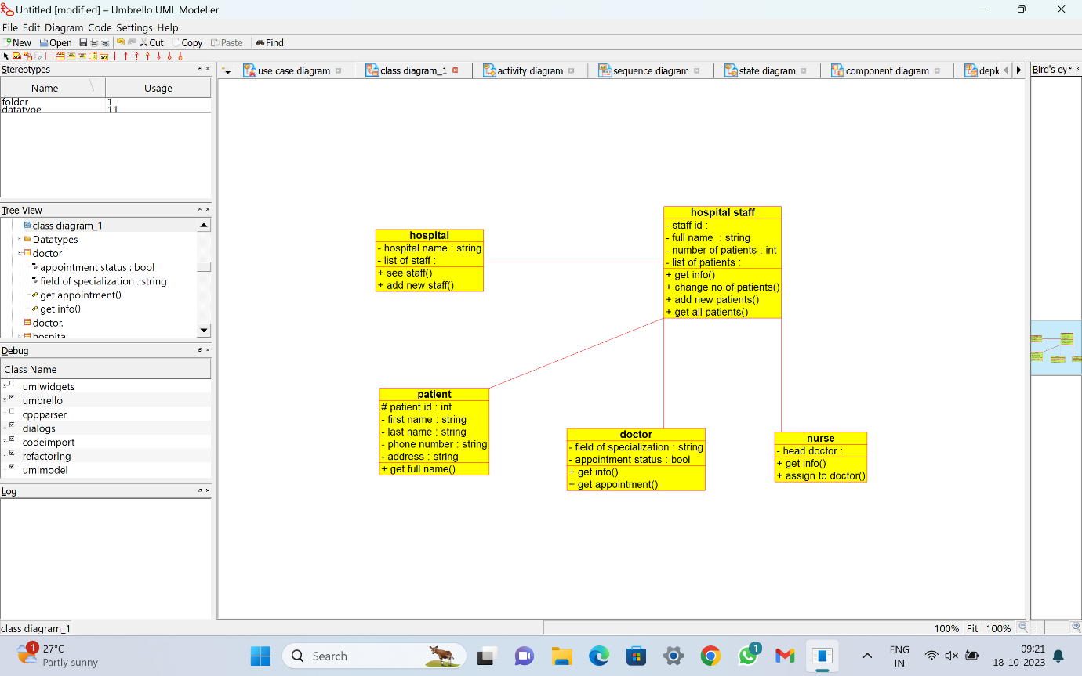

Deployment Diagram :

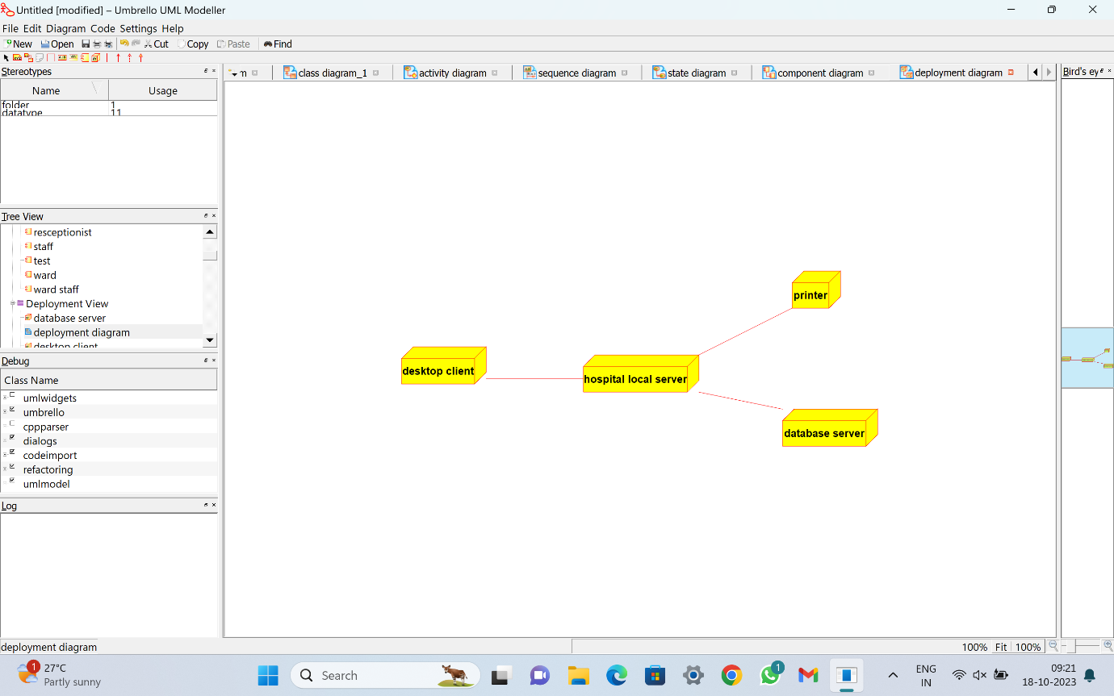

Usecase diagram :

